JD Finish Line/Dsco Ship Mapping

Version 1.0

Date 05/03/2021

Document Information
Author: | Carol Logan clogan@finishline.com | Date: 5-3-2021
Peer Reviewers | Nate Nitsch | 5-3-2021
Version Changed By

Table of Contents
1 Document Purpose 2
2 System /application References 2
3 Procedure Instructions 2
3.1 Background 2
3.2 How to Instructions 2
3.3 Support

- Document Purpose
.The purpose of this document is to support JD Finish Line suppliers

……….

The following terms or acronyms are used within this document.
Term/Acronym | Definition/Description
Dsco | An integration platform that creates networks for supply chain that simplifies the exchange of data for drop ship
Ship Via | A code that represents a carrier and type of delivery service for an order to be delivered. Example: GND=Ground

- System /application References
Access is needed for the following systems or applications.
System or Application Name | Version | Comments
Dsco | 3.0

- Procedure Instructions

Background
The main purpose of the Dsco Ship Mapping tool is to allow suppliers and retailers the ability to use their own shipping service level codes when sending/receiving order shipment messages. Using the Dsco Ship Mapper tool, a retailer can send an order with their carrier and service level information to Dsco where Dsco will update the carrier and service level to their generic codes before sending to the supplier. If a supplier configures their ship mapper with Dsco’s generic codes to their specific carriers and codes, the order message will come in as expected.

JD Finish Line requires our partners to configure the ship mapping tool. Our accepted configuration is for UPS, FedEx, USPS, Lasership and OnTrac.

UPS | FedEx | USPS | Lasership | OnTrac
UNDA | FE2D | USPS | LA2D | ON2D
UPCG | FESO |  | LACG | ONCG
 |  |  | LAND | ONND
JD Finish Line currently has the following mapped:

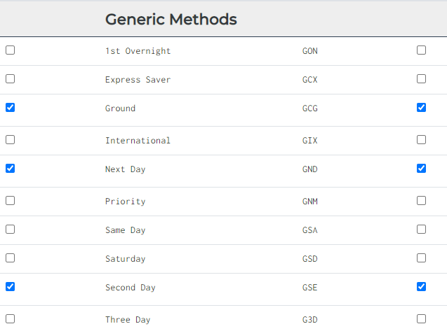

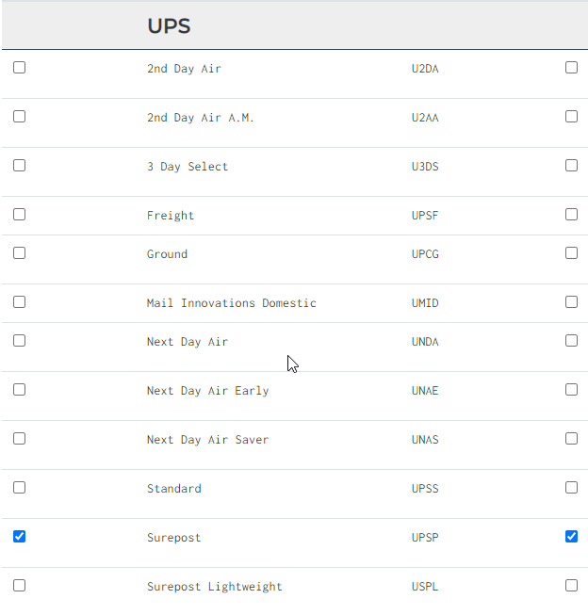

How to Instructions
Follow the Dsco Setting up Supplier Ship Mapping located:
https://support.dsco.io/hc/en-us/articles/236025787-Setting-up-Supplier-Ship-Mapping

NOTE: JD Finish Line carriers should be highlighted on your view. If not, please contact Dsco Support at link listed below.

Support
If you need additional support during configuration, please contact Dsco support at:
https://support.dsco.io/hc/en-us/requests/new

